Use Google Gemini in Colab to write a function that reads a CSV file and calculates
mean, min, max.
Output#1
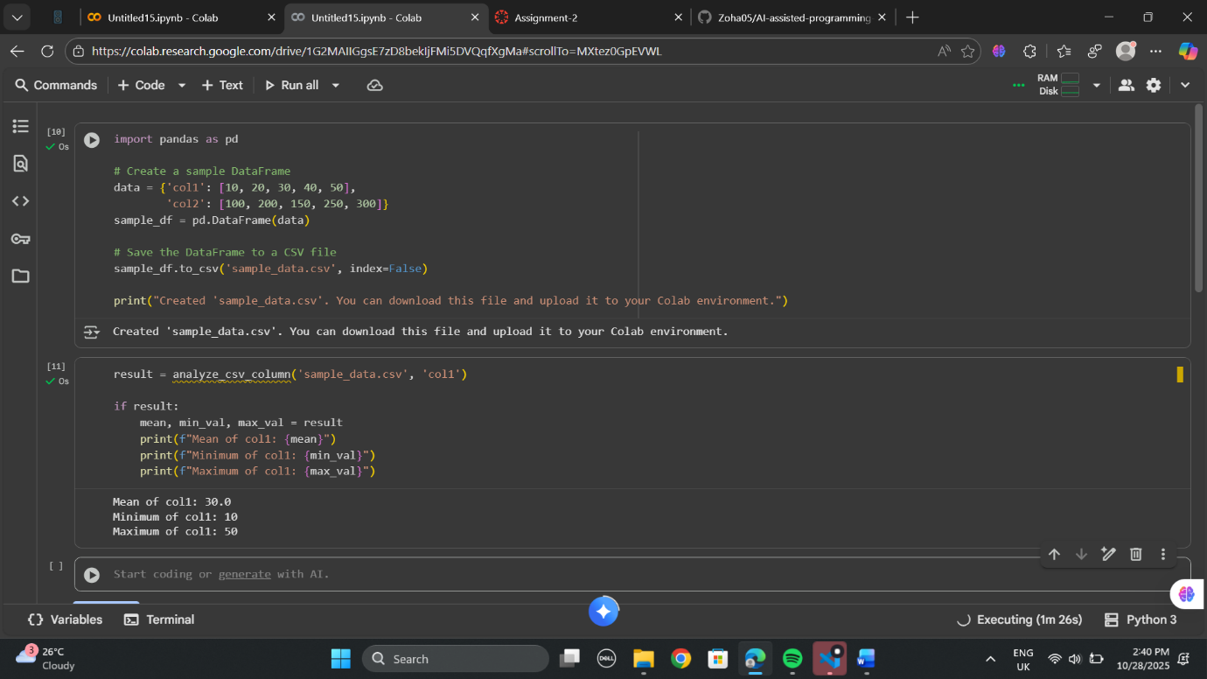

2. Compare Gemini and Copilot outputs for a palindrome check function

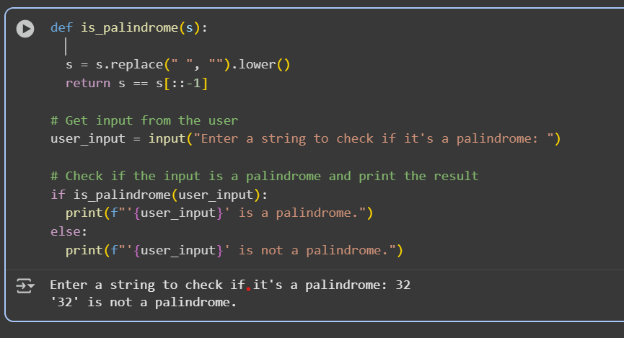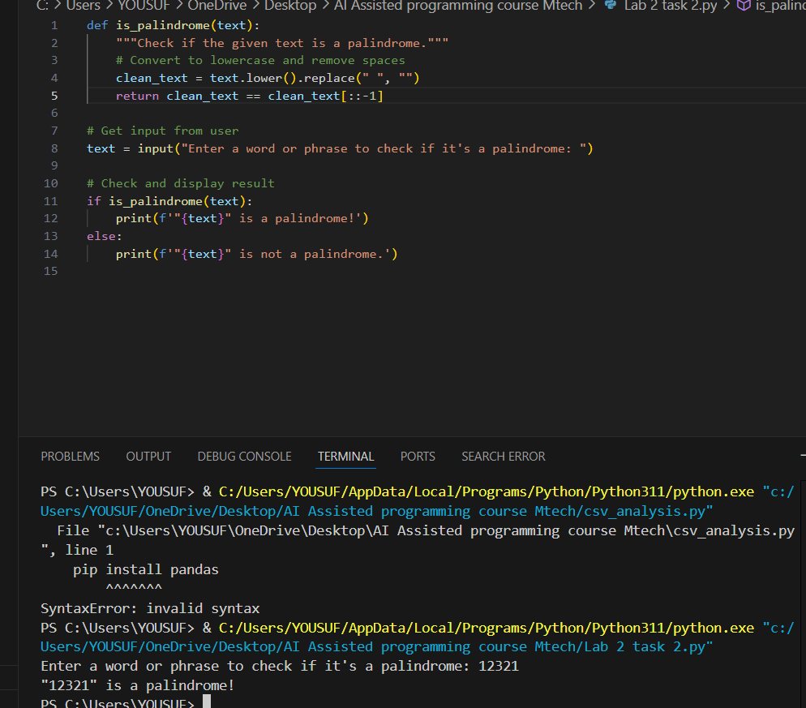

3. Ask Gemini to explain a Python function (to calculate area of various shapes) line by
line.

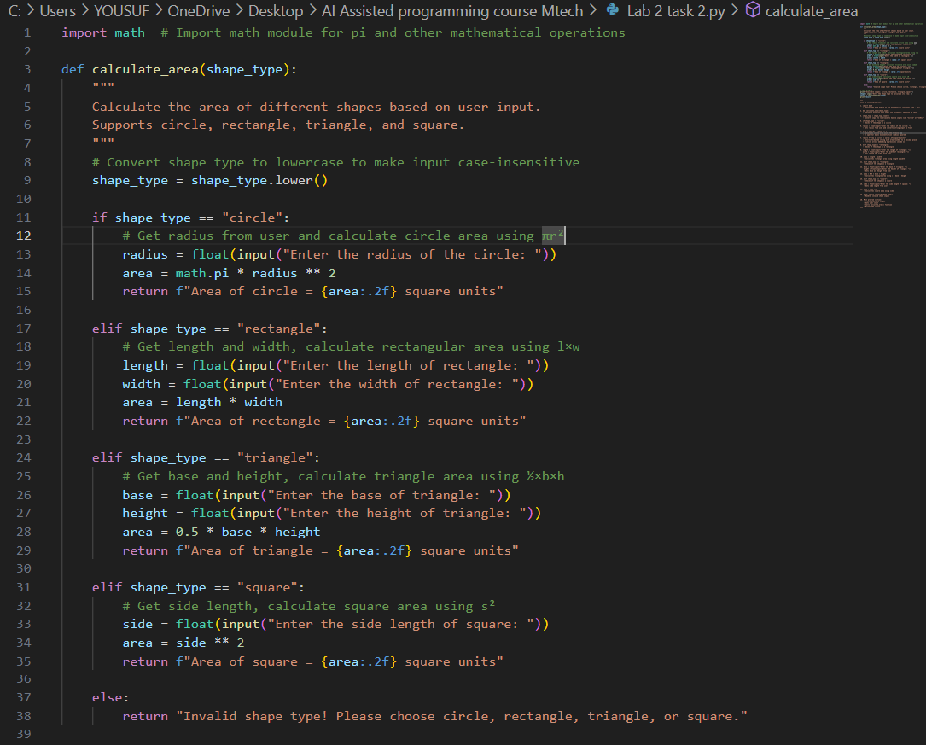

OUTPUT:

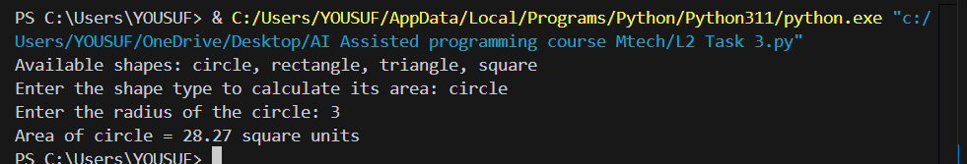

Line by Line Explanation:

1. import math
- Imports the math module to use mathematical constants like π (pi)
2. def calculate_area(shape_type):
- Defines a function that takes one parameter: the type of shape
3. shape_type = shape_type.lower()
- Converts input to lowercase to handle inputs like "Circle" or "CIRCLE"
4. if shape_type == "circle":
- Checks if the shape is a circle
5. radius = float(input("Enter the radius of the circle: "))
- Gets radius from user and converts string input to float
6. area = math.pi * radius ** 2
- Calculates circle area using the formula πr²
- ** operator means exponentiation (radius squared)
7. return f"Area of circle = {area:.2f} square units"
- Returns formatted string with area rounded to 2 decimal places
- f-string allows embedding expressions inside {}
8. elif shape_type == "rectangle":
- Checks if the shape is a rectangle
9. length = float(input("Enter the length of rectangle: "))
width = float(input("Enter the width of rectangle: "))
- Gets length and width from user
10. area = length * width
- Calculates rectangle area using length × width
11. elif shape_type == "triangle":
- Checks if the shape is a triangle
12. base = float(input("Enter the base of triangle: "))
height = float(input("Enter the height of triangle: "))
- Gets base and height from user
13. area = 0.5 * base * height
- Calculates triangle area using ½ × base × height
14. elif shape_type == "square":
- Checks if the shape is a square
15. side = float(input("Enter the side length of square: "))
- Gets side length from user
16. area = side ** 2
- Calculates square area using side²
17. else: return "Invalid shape type!"
- Handles invalid shape inputs

4.generate a Python function (e.g., sum of
squares)

